SCREEN SHOTS OF PROJECT

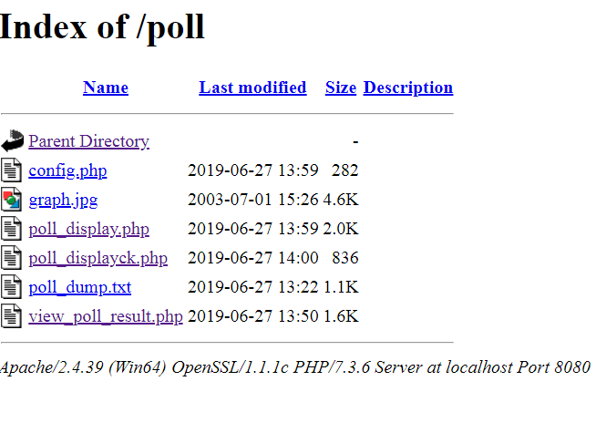

CLICK ON POLL_DISPLAY TO GET

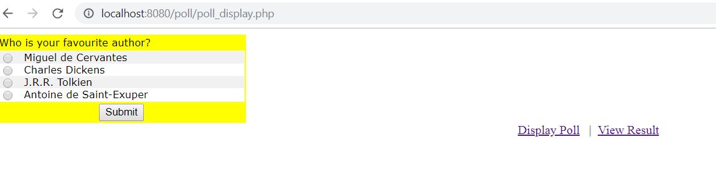

CHOSE AND SUBMIT

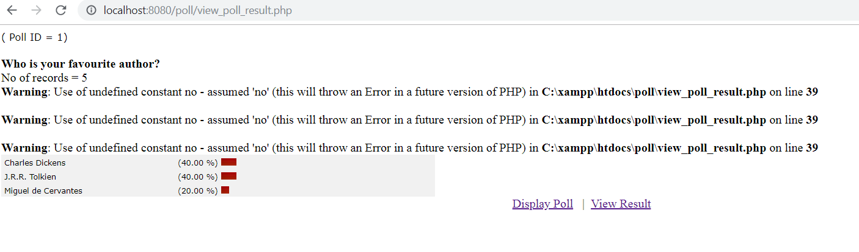

WARNING ARE BECAUSE OF OLDERVERSION(NO WORRRY)